SCALA PROGRAMMING

NAME : MARIDI SAI SATHVIKA REDDY

USN : 22BTRAD024

COURSE : CSE AI DE

Q. Write a Scala program that creates an abstract class Shape with an abstract method area. Implement subclasses Rectangle and Circle that override the area method.

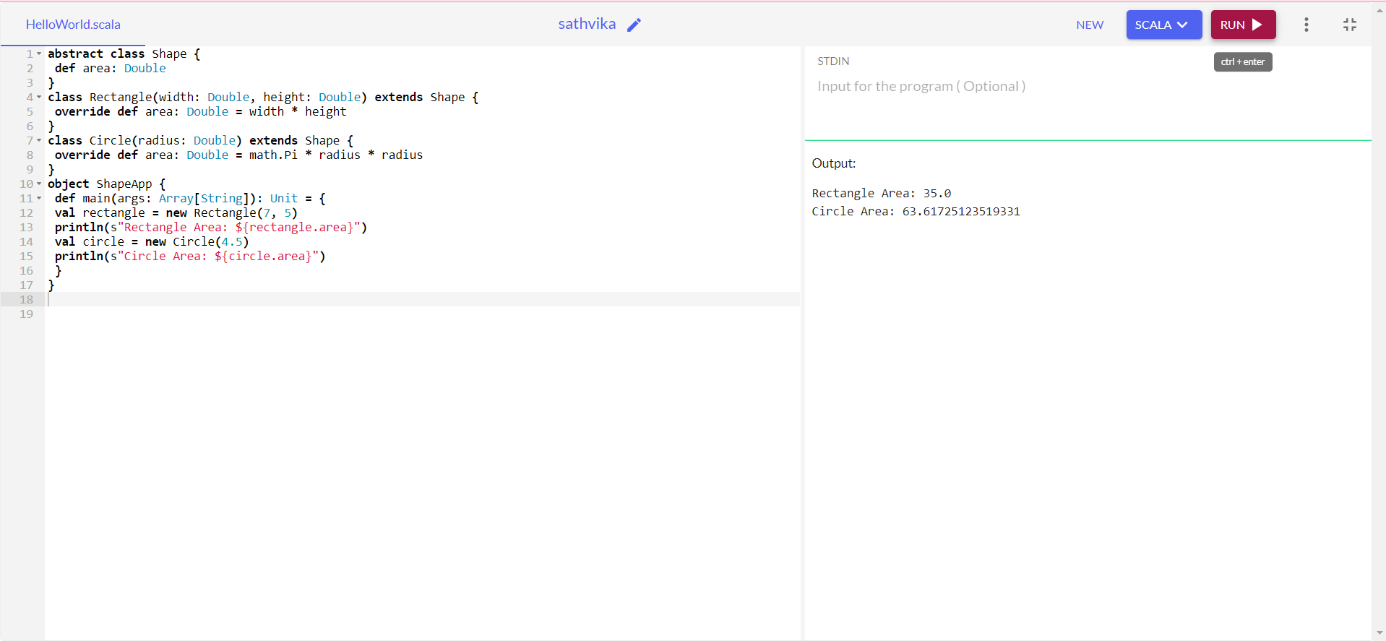

CODE:

abstract class Shape {

def area: Double

}

class Rectangle(width: Double, height: Double) extends Shape {

override def area: Double = width \* height

}

class Circle(radius: Double) extends Shape {

override def area: Double = math.Pi \* radius \* radius

}

object ShapeApp {

def main(args: Array[String]): Unit = {

val rectangle = new Rectangle(7, 5)

println(s"Rectangle Area: ${rectangle.area}")

val circle = new Circle(4.5)

println(s"Circle Area: ${circle.area}")

}

}